PROGRAMS USING RAPTOR:

1. C Program to solve quadratic equation

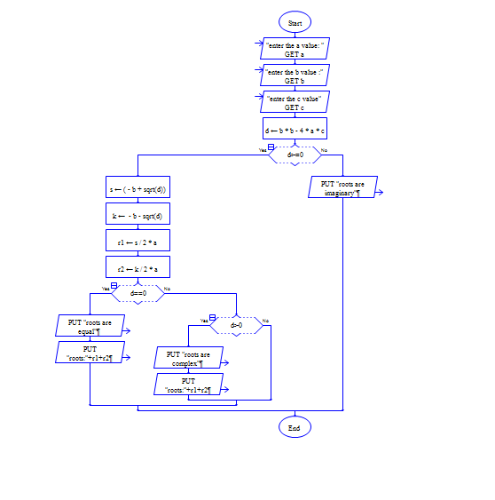

1. C Program for decimal to binary conversion
2. C Program factorial using recursion
3. Write a C script to ask your name, program name and enrollment number and print it on the screen.

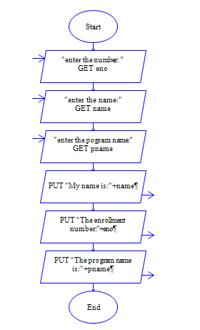

1. Write a C script to find the sum, the average and the product of the four integers entered

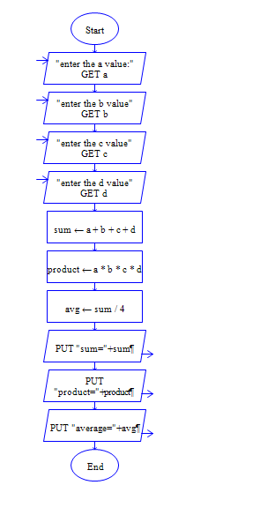

1. Write a C program to exchange the values of two variables

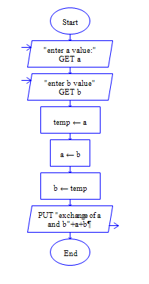

1. Write a C script to display the digits which are in odd position in a given 5 digit number
2. Write a C program to reverse the digits of five digit integer

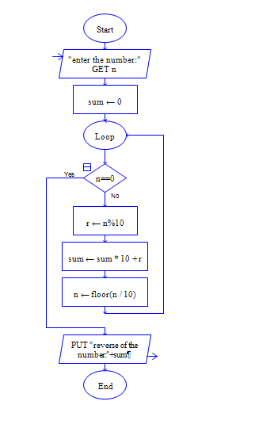

1. Write a C program to concatenate two strings and find the length of the resultant string
2. Write a C program to find the position of substring in given string
3. Write a C program to find the gcd for the 2 given numbers
4. Write a C program to add, subtract and multiply the 2 given numbers

